Brockington Excellence Programme

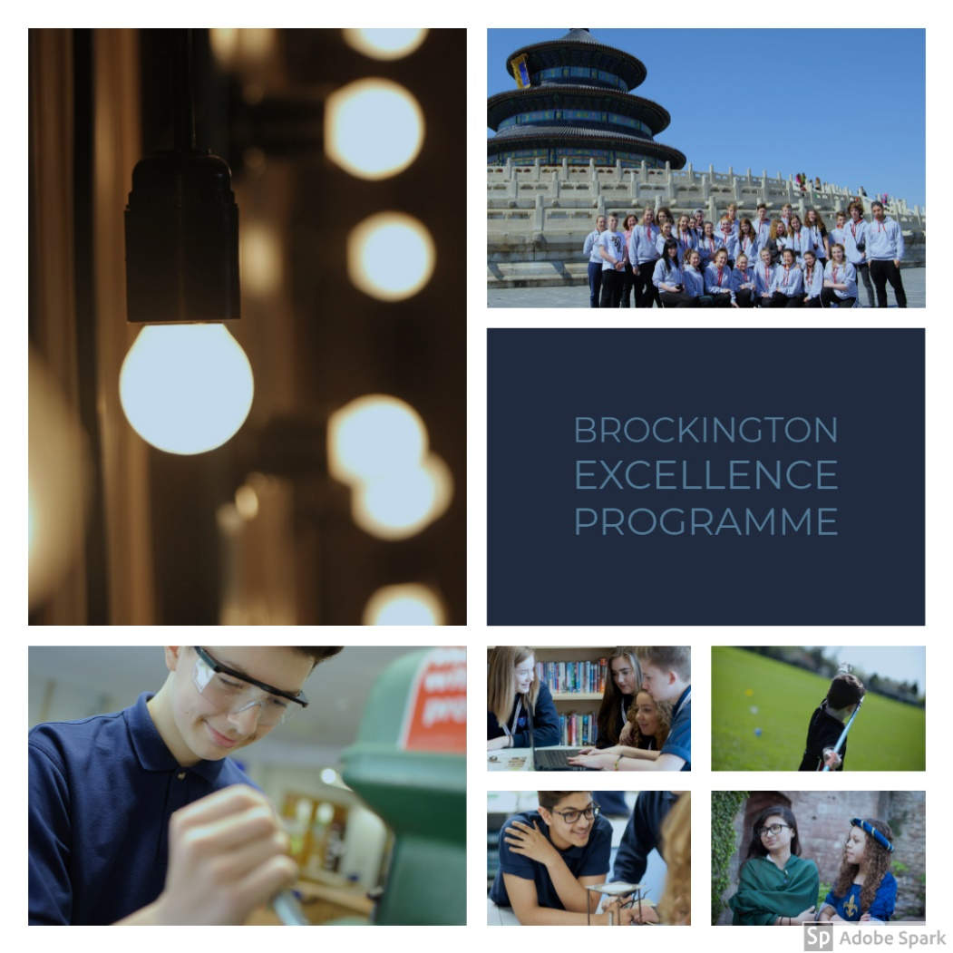

Personal Details

Name: | Tutor Group:
ID: (a photograph of yourself) | Image: (something that really represents or interests you)
My aim:

Introduction

You are able and talented; the Brockington Excellence Programme gives you the opportunity to show and develop your abilities, talents and skills.

The Brockington Excellence Programme is a nine point challenge. Whilst you are here, you will have access to some of the best that the College has to offer its students.

If you complete all nine challenges, you can be proud of your achievement; this will act as a document to provide to Colleges or Universities for interviews, or help you to complete an application form, whatever you next steps may be. You will have enjoyed a variety of different experiences, tried a few new things and found something you enjoy and excel at. There will also be a reward for completing all nine challenges.

The nine point promise consists of:

- Have your say on Brockington issues and affairs

- Celebrate your talents

- Get involved in a public event at the College

- Join a club at Brockington or outside of school

- Master a Subject

- Take part in public speaking

- Help others through voluntary work

- Visit a college or university to think about your next steps

- Develop as a Leader

- Aspirational Extra

- Student Voice: Have your say on Brockington issues and affairs
- This is your school and you are an important part of making it a vibrant, happy place where everyone can learn and grow.

- Air your views, both positive and negative, concerning the school, community and make suggestions about how we can work together to improve.

- You can do this by putting yourself forward to represent your tutor group, taking part in the School council, taking part in any student voice activities on offer, or by speaking to the Leadership team about your concerns on a matter.
One achievement is enough but go the extra mile:
I did this:

Signed and dated:
I did this:

Signed and dated:

I did this:

Signed and dated:

- Celebrate your talents
- You can do this individually, as part of a school team, music group or as part of a club/group outside of school.
- The possibilities are endless! Swimming, debating, tennis, rugby, football, art, Gymnastics, scouting, drama…
- Whatever your talent, develop it and let us know what you have achieved so we can celebrate your success with you.
- The skills you develop by being involved at the College or in the community will open up so many opportunities for the future!
One achievement is enough but go the extra mile:
I did this:

Signed and dated:
I did this:

Signed and dated:

I did this:

Signed and dated:

- Get involved in a public event at the College
- Get involved in a public display, such as a sporting event, assembly, open evening, sport or musical event or art exhibition.
- Music, art, dance and sport all offer opportunities for you to show others the result of your hard work.
- These events will help you to face new challenges and develop skills.
One achievement is enough but go the extra mile:
I did this:

Signed and dated:
I did this:

Signed and dated:

I did this:

Signed and dated:

- Join a club at Brockington or outside of school
- This could be a sports team, dance group, lecture club, debating club, STEM, Duke of Edinburgh, Scouts, Guides- it’s up to you. If you cannot find a club that interests you, why not find a willing teacher and start up your own?
- Clubs will enable you to meet and get to know other students that like the same things as you do.

One achievement is enough but go the extra mile:
I did this:

Signed and dated:
I did this:

Signed and dated:

I did this:

Signed and dated:

- Master a subject
- Attend a subject masterclass or complete the subject-specific toolkit to enhance your understanding of a subject. There are subjects that you will find you excel at- why not get more involved by challenging yourself?
- Attending a masterclass will help you to achieve grades of an even higher standard and ignite your passion for a subject.
One achievement is enough but go the extra mile:
I did this:

Signed and dated:
I did this:

Signed and dated:

I did this:

Signed and dated:

- Take part in public speaking
- Take any opportunities to speak in public. This could be an assembly, open morning, interview panel tours, awards evenings or in class.
- The ability to speak with confidence is such an important life skill that you will need in almost every career in the future.
- Speaking to a range of people in a variety of scenarios will prepare you for your own next steps once you leave the College.

One achievement is enough but go the extra mile:
I did this:

Signed and dated:
I did this:

Signed and dated:

I did this:

Signed and dated:

- Help others through voluntary work
- Do you feel strongly about helping those in the community who may be struggling? Why not help others through voluntary work?
- This could be as a mentor, prefect, charity rep; you may fundraise for a charity event or regularly volunteer at a local venue.
- Volunteering is such a rewarding process and will help you not only to empathise with and understand others, but help you to develop people skills that will help you throughout life.
One achievement is enough but go the extra mile:
I did this:

Signed and dated:
I did this:

Signed and dated:

I did this:

Signed and dated:

- Visit a College or University to think about your next steps
- Take the opportunity to visit a college or university, either locally or further afield.
- This type of visit will provide you with information about their available courses and may help you to consider what you would like from the next point in your education and future career.
- Make informed choices about your future by thinking about these steps; you may be surprised at the range and variety of courses available to you!
One achievement is enough but go the extra mile:
I did this:

Signed and dated:
I did this:

Signed and dated:

I did this:

Signed and dated:

- Develop as a leader
- Become involved in reading mentoring, student voice, Prefect or Head Girl/Boy- there are so many opportunities to lead at the College.
- Train and deliver sessions as a Sports Leader, or become a captain of a sports team.
- You could be involved in Digital Leaders or support House Leaders in events.
- Leadership qualities are a vital skill that will help you in later life.
One achievement is enough but go the extra mile:
I did this:

Signed and dated:
I did this:

Signed and dated:

I did this:

Signed and dated:

- Aspirational Extra
- Use this tenth challenge to record other achievements that you have been involved in and are proud of. These may include things that you have achieved outside of school but did not record in the other ten areas.
- You may have gained an award or prize, achieved your personal best at an event or just be something that you are incredibly proud of.

One achievement is enough but go the extra mile:
I did this:

Signed and dated:
I did this:

Signed and dated:

I did this:

Signed and dated:

